1. **Найти самый дорогой товар. Вывести его название и цену.**

SELECT goods.name, prices.value

FROM goods

JOIN prices ON goods.id = prices.goods_id

WHERE prices.value = (

SELECT MAX (value) FROM prices

);

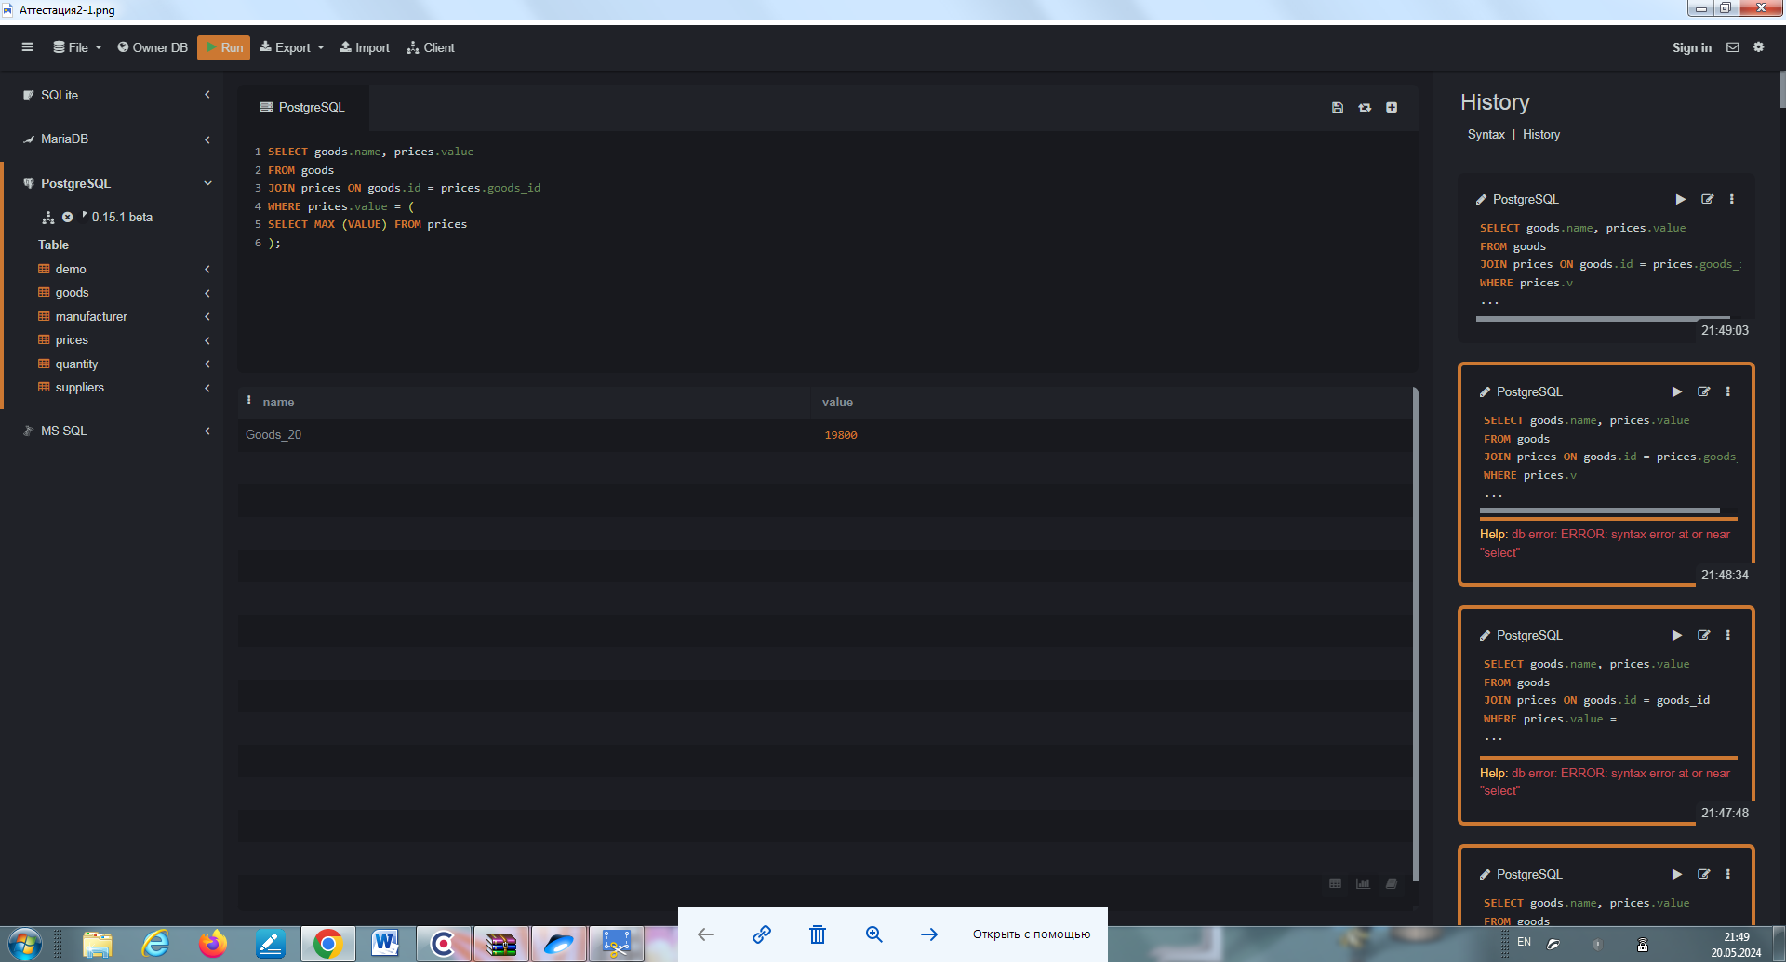

1. **Найти товары с нулевым остатком. Вывести имя товара и его цену**

SELECT goods.name, prices.value

FROM goods

INNER JOIN prices ON goods.id = prices.goods_id

INNER JOIN quantity ON goods.id = quantity.goods_id

WHERE quantity.value = 0



1. **Найти производителя с самой большой средней ценой за товары. Вывести имя производителя и цену товара**

SELECT AVG (prices.value), manufacturer.name

FROM goods

INNER JOIN suppliers ON goods.supplier_id = suppliers.id

INNER JOIN prices ON goods.id = prices.goods_id

INNER JOIN manufacturer ON suppliers.manufacturer_id = manufacturer.id

GROUP BY manufacturer.name

ORDER BY AVG (prices.value) DESC

LIMIT 1

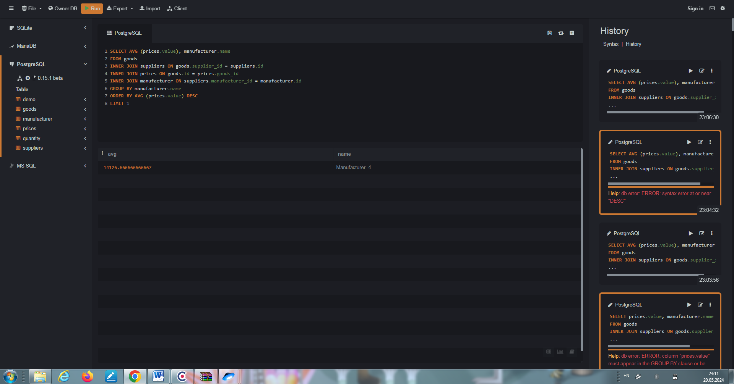

1. **Найти все товары производителей из Москвы. Вывести имена товаров, цену и производителей.**

SELECT goods.name, prices.value, manufacturer.name

FROM goods

INNER JOIN prices ON goods.id = prices.goods_id

INNER JOIN suppliers ON goods.supplier_id = suppliers.id

INNER JOIN manufacturer ON suppliers.manufacturer_id = manufacturer.id

WHERE manufacturer.location = 'Moscow'

